Emotions Recognition System

S. R. S. Report – I

Group No.-61

**Team Members**

Mohd Firoj

(161300052)

Sujeet Kumar Singh

(161500569)

Shashank Mittal

(161500504)

Ayush Gupta

(161500158)

**Table of Contents**

Revision History ii

Document Approval ii

1. Introduction 1

1.1 Purpose 1

1.2 Scope 1

1.3 Definitions, Acronyms, and Abbreviations 1

1.4 References 1

1.5 Overview 1

2. General Description 2

2.1 Product Perspective 2

2.2 Product Functions 2

2.3 User Characteristics 2

2.4 General Constraints 2

2.5 Assumptions and Dependencies 2

3. Specific Requirements 2

3.1 External Interface Requirements 3

3.1.1 User Interfaces 3

3.1.2 Hardware Interfaces 3

3.1.3 Software Interfaces 3

3.1.4 Communications Interfaces 3

3.2 Functional Requirements 3

3.2.1 <Functional Requirement or Feature #1> 3

3.2.2 <Functional Requirement or Feature #2> 3

3.3 Use Cases 3

3.3.1 Use Case #1 3

3.3.2 Use Case #2 3

3.4 Classes / Objects 3

3.4.1 <Class / Object #1> 3

3.4.2 <Class / Object #2> 3

3.5 Non-Functional Requirements 4

3.5.1 Performance 4

3.5.2 Reliability 4

3.5.3 Availability 4

3.5.4 Security 4

3.5.5 Maintainability 4

3.5.6 Portability 4

3.6 Inverse Requirements 4

3.7 Design Constraints 4

3.8 Logical Database Requirements 4

3.9 Other Requirements 4

4. Analysis Models 4

4.1 Sequence Diagrams 5

4. 2Data Flow Diagrams (DFD) 5

4.3 ENTITY RELATIONSHIP DIAGRAM 5

A. Appendices 5

A.1 Appendix 1 5

A.2 Appendix 2 5

## 1. Introduction

Emotions in Social Psychology, in which it explained the emotion system and formally classified the human emotions through an emotion hierarchy in six classes at primary level which are Love, Joy, Anger, Sadness, Fear and Surprise. Certain other words also fall in secondary and tertiary levels. People are able to perfectly distinguish the expressed emotions because they understand the meaning of the words and phrases. They also are able to generate expressions and sentences for different emotions.

## Purpose

## The purpose of this SRS document is to provide a detailed overview of our software product, its parameters and goals. This document describes the project's target audience and its user interface, hardware and software requirements

## 1.2 Scope

(1) Emotions Recognition System

(2) Our software will be able to recognize different types of emotions like Happy, Sad, Angry and Neutral.

(3) Applications

(a) Health care-patient feelings about treatment, It can be used in call centers,

## 1.4 References

<https://www.kaggle.com>

<https://www.google.com>

<https://www.udemy.com>

## 1.5 Overview

# Chapter 2 will provide the overall description of the application.

Chapter 2.1 will contain the System Environment for the application

Chapter 2.2 will contain the Functional Requirements Specification for the application

Chapter 2.3 will contain the User Interface Specification for the application

Chapter 2.4 will contain the Non-Functional Requirements for the application

Chapter 3 will contain the Requirement Specification for the application

Chapter 3.1.1 will contain User Interfaces

Chapter 3.1.2 will contain Hardware Interfaces

Chapter 3.1.3 will contain Software Interfaces

Chapter 3.2 will contain the Functional Requirements for the application

Chapter 3.2.2 will contain Register Use Case

Chapter 3.2.3 will contain Class/objects

# 2. General Description

# Emotion recognition is the ability of a machine or program to receive and interpret dictation or to understand and carry out spoken commands. Voice recognition has gained prominence and use

## 2.1 Product Perspective

There can be many products similar to emotion recognition system but their functionality may be different in context that they recognize human facial expressions or just voice which can be used for some specific purposes.

## 2.2 Product Functions

This software will be able to recognize human emotions like happy ,sad, neutral , angry by taking the input as voice and will be able to identify the type of emotion.

## 2.3 User Characteristics

It will be taking voice of user as input so that it in this context voice of user will be used. This would help to recognizing of emotions by the user.

## 2.4 General Constraints

Here the developers will be able to recognize the emotions with the help of 30,000 emotions dataset containing different speech words for same type of emotions.

## 2.5 Assumptions and Dependencies

This software will be able to work upon on all types of operating system but not with the old versions of operating systems which are usually very old.

# 3. Specific Requirements

## 3.1 External Interface Requirements

### 3.1.1 User Interfaces

The user interface will run on windows.

### 3.1.2 Hardware Interfaces

The Emotion Recognition system require a laptop that have Intel Core i3 processor with 4GB RAM

### 3.1.3 Software Interfaces

There are no external software interface requirements.

### 3.1.4 Communications Interfaces

There are no external communications interface requirements

## 

## 3.2 Functional Requirements

## 3.3 Use Case

SYSTEM

Input

Speech

## 

Speech

User Detection

Feature

Extraction

Classification System

Emotion

## 3.4 Classes / Objects

### 3.4.1 APP

3.4.1.1 Mic_switch: Boolean

Recognizer: Recognizer

Microphone: Microphone

isTrained: Boolean

3.4.1.2 loadFrameComponents():Void

Run(): Void

doCommandRecogntion(resultText): String

### 3.4.2 ActionListener

3.4.2.1 addActionListener(this): Event

actionPerformed(ActionEvent): Event

### 3.4.3 ProcessManger

3.4.3.1 Computer: String

CurrentProcess: Process

3.4.3.2

CurrentProcess: void()

runComputer(): Void()

runWord(): Void()

## 3.5 Non-Functional Requirements

### 3.5.1 Performance

1- System should recognize to any voices in his list without any fault.

2- With Ideal conditions, system response should be fast and error free.

3- System performance shall not decrease with time or by usages.

### 3.5.2 Reliability

The system wiil be available 100% of the time.

### 3.5.3 Availability

This system wiil be up to date and offer all the facilities to the users. Also view the right detection.

### 3.5.4 Security

1- Change the data is only allowed to admins and forbidden to any user.

2- Program run without web, that is mean protected from hackers.

## 3.5.5 Maintainability

Software development team will be the maintenance team for any error or defect.

### 3.5.6 Portability

1- The system can never crash.

2- The system must produce predictable result.

## 3.6 Inverse Requirements

It will not work on videos. It will work on data set which we will give by text.

## 3.7 Design Constraints

1- No company policy.

2- No hardware limitations.

## 3.8 Logical Database Requirements

Database will not use.

## 3.9 Other Requirements

No other requirements.

# 4. Analysis Models

## 4.1 Sequence Diagrams

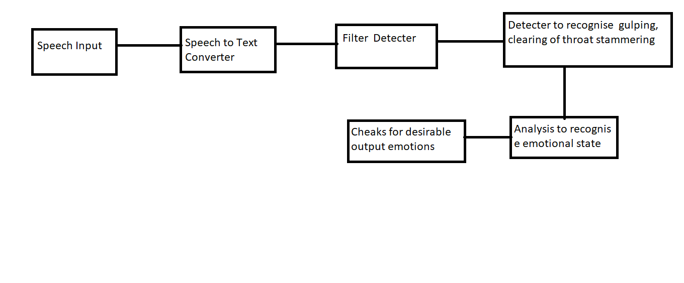

## 4.2 Data Flow Diagrams (DFD)

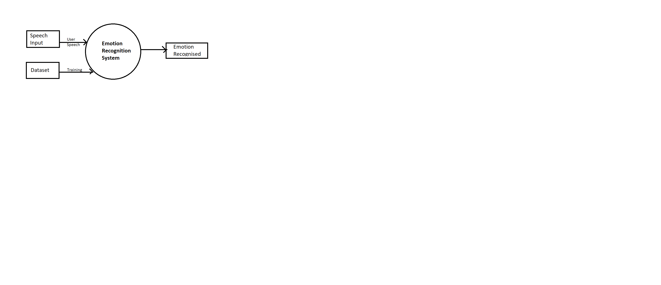

## 4.3 Entity Relationship Diagrams (ERD)

